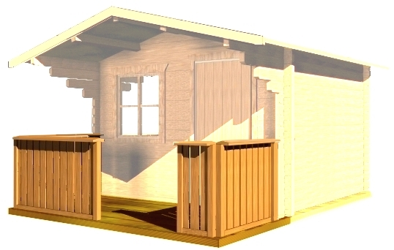

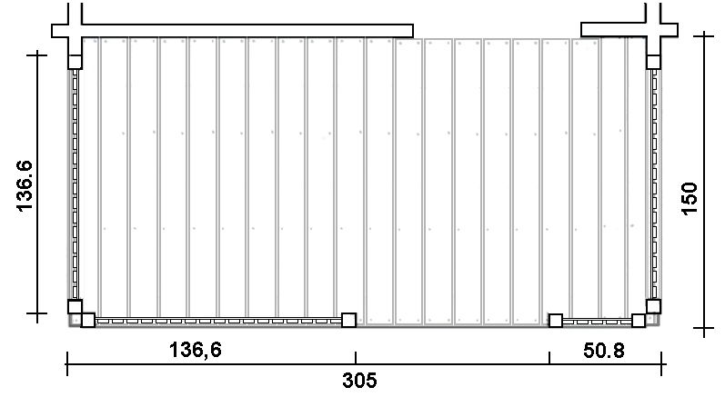
Consists of:

20 mm floor boards with inter-board spaces on the impregnated fundament frame. 4 units of fences with railings. It is possible to join to log cabins T12, T14, T15, T17, T23.

